UNIVERSITY OF DAR ES SALAAM



COLLEGE OF INFORMATION AND COMMUNICATION TECHNOLOGIES (CoICT).

DEPARTMENT OF ELECTRONICS AND TELECOMMUNICATION ENGINEERING.

ES 499: FINAL YEAR PROJECT

PROGRESS REPORT

|  |  |
| --- | --- |
| PROJECT TITTLE: | SECURED WIRELESS USB FLASH DRIVE. |
| STUDENT`S NAME: | KOWERO, WALIDI WAZIRI |
| REG. NO: | 2020-04-04390 |
| PROGRAM: | BSc. IN ELECTRONICS ENGINEERING |
| SUPERVISOR`S NAME: | PROF BARAKA MAISELI. |
| SUPERVISOR’S SIGNATURE: | ……………………………. |
| STUDENT’S SIGNATURE: | ……………………………. |
| SUBMISSION DATE: | 2nd , FEBRUARY 2023 |

# ABSTRACT

This project aims at utilizing this advancement in technology that we have achieved so far to develop a secured wireless system that can perform seamless data transfer to the client over different operating systems. The system tries to increase the mobility and freedom and provide more options to the user towards the access of information.

TABLE OF CONTENTS

ABSTRACT i

LIST OF FIGURES iii

LIST OF ABBREVIATIONS iv

CHAPTER ONE 1

INTRODUCTION 1

Background 1

PROBLEM STATEMENT 3

OBJECTIVES 3

Main objective 3

Specific Objectives 3

LITERATURE REVIEW 4

METHODOLOGY 5

Concept Generation 8

Block Diagram 8

Flowchart 9

Use Case 12

Relation Diagram 14

Sequence Diagram 14

CHALLENGES 15

WORK DONE SO FAR 15

TIME SCHEDULE 18

BUDGET 19

REFERENCES 20

# LIST OF FIGURES

Figure 1 Basic Scheme of a semiconductor memory cell 1

Figure 2 A typical USB Flash Drive 5

Figure 3. A modified Block diagram of a system 8

Figure 4 The main program workflow 9

Figure 5. Samba Server Flowchart 10

Figure 6. Web Server Flowchart 11

Figure 7. Use Case 12

Figure 8. Entity relation diagram 13

Figure 9. Sequence diagram 14

Figure 10. Web page for file management 15

Figure 11. Simulation of Webserver on WOKWI Online Electronics Simulation Platform 16

Figure 12 Gantt chart 17

# LIST OF ABBREVIATIONS

|  |  |
| --- | --- |
| **Abbreviation** | **Long form/meaning** |
| CUWB | Ciholas Ultra-wideband |
| eMMC | Embedded Multimedia card |
| SMB | Server Message Block |
| NAS | Network attached Storage |
| NFS | Network File system |
| USB | Universal Serial Bus |
| UWB | Ultra-wideband |
| Wi-Fi | Wireless Fidelity |

# CHAPTER ONE

## INTRODUCTION

### Background

Majority of the storage technology have been largely improved in term of speed, capacity and reliability over the past 20 years. Some of the major discovery include

* discovery of Magnetic tape (1930) which uses a plastic tape containing magnetic material which creates a certain pattern of potential difference when passed through magnetic sensor. This pattern is the data stored in the tape (Bogart, 1995),
* discovery of Magnetic disk drive (1956) which uses a metallic circular disk with magnetic property rotating with high speed whereas data is stored within each circumference in the disk. The magnetic sensor then is placed with displacement of a varying disk radius to read the data. This data I is then analyzed to information [2] and
* discovery of semiconductor memory cell (1967) which uses a floating gate technology to store data in form of charging a capacitor where by the electrons a trapped within the floating layer (Bogart, 1995).

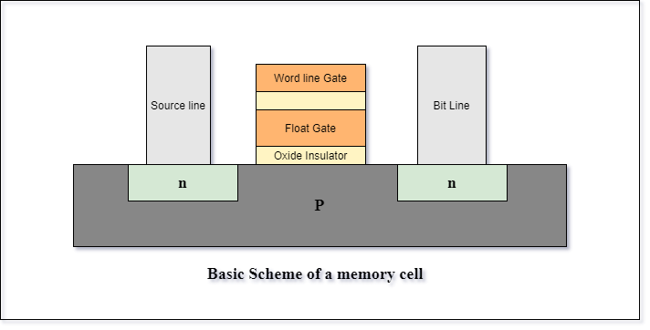

Figure 1 Basic Scheme of a semiconductor memory cell

This discovery has then led to two major discoveries based on the configuration involved:

1. Nand Memory: whereby the memory device is formed by parallel arrangement of semiconductor memory cells while
2. Nor Memory are formed by a serial arrangement of semiconductor memory cells

(Hyperstone, 2020)

In the current world as far as the current technology is concerned, there have been a lot of advancement of storage technologies. Since the early 2000s, as the microelectronics world rapidly changes from small scale integration to very large integration, the technology of storages has been simultaneously increasing toward higher scale of integration.

This increase in technology has allowed vasty increase in storage capacity over the time from several kilobytes that was stored in floppy disks and tapes to several Terabytes that can be stored in hard disks drives and solid-state drive.

Most of devices in the present time usually stores up to several gigabytes that can achieve up to 600 megabytes per second for reading and writing speed. These devices can be used for storage, data transfer or booting process.

Development of portable disk drives like USB flash drive, portable external hard disks and compact disks has been increasingly adopted over the years which lead to increasingly large number of flash disks in the market which does not satisfy the actual needs of the local market like compatibility, storage, costs and durability.

Furthermore, the increase adoption of the wireless radio communications protocols like Wi-Fi and Bluetooth has led to increase in reliability and flexibility to access data seamlessly over many applications like IoT systems, automation systems as well as industrial systems.

These wireless communications protocols have been used so far to transfer data and information over the internet and other subnetworks whereby some can even achieve up to 900 megabytes per second.

This project aims at reviewing and implement wireless storage system to the local market by using Nand memory since it is cheaper than the nor memory based on the research results done at the previous practical training.

The main stakeholders for this project are the local market of Tanzania.

## PROBLEM STATEMENT

Traditional memory storages rely on physical connections like wires which serves a great deal of disturbance when mobility is needed. Also, some wires tend to be bulk and heavy to carry. Some of the improved state-of-the-arts of today uses ports like Usb connectors which in spite of having a very high data transfer rate, sometimes are prone to fatigue after a long run of use.

Also, the security for this kind of existing storage connections is weak therefore there is a need for a better way of connecting the storage devices with and without physical connection. This will help in improving the portability, flexibility and security of the existing storage devices.

In spite of currently existing technology and advancement of wireless technology like the existence of

* Network Attached Storage (NAS) which are mainly served by the NAS server.
* SanDisk Connect wireless stick flash drive which offers storage capacity of up to 200GB and a good transfer speed but it is only supported on its software.
* Asus Travelair N a wireless SSD drive which can offers up to 1TB of storage.

As far as the current technology is concerned, the storage solutions fail short of simplicity, compatibility, flexibility and security. In some solutions like SanDisk wireless flash drive, some parameters like compatibility and security have been solved with highest priority while trading off other parameters like flexibility.

There is a need for research and development to bridge this gap and create a reliable, user-friendly, and secure wireless alternative that may ensure good and reliable data management accompanied with security.

## OBJECTIVES

### Main objective

To enhance flexibility and security in wireless flash storage devices.

Specific Objectives

1. To enable reliable wireless data transfer: by enabling data transfer and access with both physical and wireless connections. In this term portability and convenience are considered.
2. To implement secure ways of data transfer: To implement robust security measures to ensure data is protected during transfer.
3. To implement multipoint user-friendly interfaces: To develop an intuitive and user-friendly interface that can cope with at least more than 3 operating systems with windows and Linux included.

## LITERATURE REVIEW

This project’s literature review is categorized based on the findings and topics. The classification is as follows

* Storage technologies:

1. Nand Memory technology: Based on the article published by Hyperstone on non-volatile memory, The author tries to explain theory behind the existence of NAND flash memory, characteristics, properties and different level of complexity they can achieve in term levels. (Hyperstone, 2020)
2. USB Mass storage server: in the article the author has successfully create and implement a smart usb flash drive using Raspberry Pi zero. The Pi zero acts as usb host and can be accessed wirelessly through SSH or Wi-Fi. The user can use these interfaces to manage files in the Pi zero. (Barnes, 2017)

* Wi-Fi technology:

From an article “For Wireless USB, the Future Starts Now”. The author has tried to explain the emergency of wireless USB which can be implemented over the internet. This rising technology implements the use of current advancement of radio communication and Wi-Fi protocol as the major tools. He also explained different protocols such as UWB, WUSB and CWUSB.

By utilizing the full spectrum, UWB can achieve superior performance while consuming less energy. Essentially, UWB achieves bandwidth by using low-energy pulses across a wide frequency range. The majority of other wireless technologies accomplish performance at the expense of excessive energy consumption since they only use one designated band within a frequency spectrum. (IEEE, 2007)

* Interface used:

1. This design aimed at implementing a storage device that can be accessed wirelessly though acting as a normal USB disk. The design is comprised of two separates modules, the adapter module for the interface to the PC and the storage module, which is made up of the flash memory, chip to be used as a mass storage device. These modules communicate wirelessly for as near as two meters. In this design there is no middleware needed for file transfer. Since the USB module act as a dongle, the computer treats the whole system a separate usb flash drive. (Czapor, Hartney , & Knight , 2006)
2. On another article presenting Sandisk Connect in which the designer has used middleware to transfer data across different operating system. Sandisk wireless pen drive can transfer data in both physical channel through USB and wireless channel through Wi-Fi interfaced to specified Sandisk software for file transfer. Although the product has now been in production decline since 2022 (Digital, 2022)

## METHODOLOGY

This project will follow the water-fall methodology whereas the bottom-up approach will be used to achieve the main objective. This system combines and adopts the works of other successfully works as sub modules or components responsible to accomplish a certain functionality which is then integrated to one system. The following are the key points that will be implemented to accomplish main objective of this project:

* To implementing mass storage server using the normal physical connection that is usb which will provide a user with choices that mostly fits comfortability. This is done by finishing up and utilize the existing design of flash disk drive that uses USB connector that was done as practical training III year 2023 that was done by myself with my colleague Neria I Rutashobya with registration number 2020-04-10739 as the base design for this project

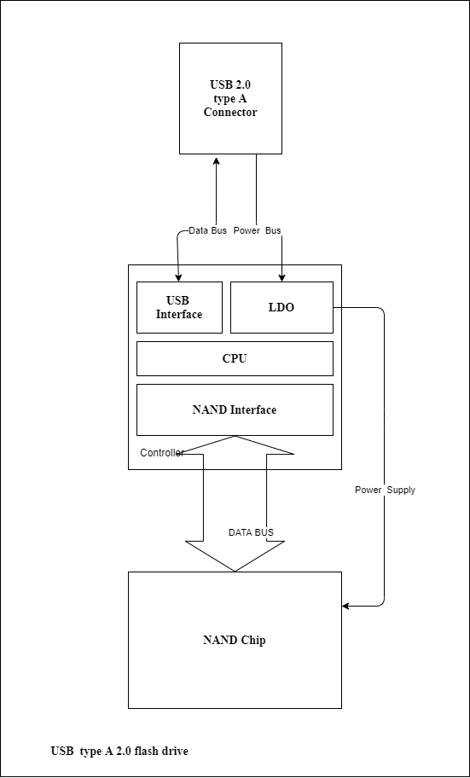

Figure 2 A typical USB Flash Drive

* To develop or utilizing the existing ways of creating a local area network wirelessly between the Host and the Client that involves the user with less handshaking process.
* To develop a robust way of data transfer between the host and the client which include using more than one data channels, modified session database to always remember session whenever there is a fluctuation/loss in connectivity.
* By utilizing the existing encryption technologies such as hybrid encryption technology which utilizes both symmetric and asymmetric encryption technology. A secured and a robust yet reliable system can be developed.
* By implement the in-built features for wireless file transfer that already exist in most of the operating systems like samba (SMB) protocol and network file sharing (NFS) protocol to reduce congestion of procedure that the user is supposed to consider in order to perform data transfer.
* By implementing a user-friendly encasing design, can provide user with a comfortability and enhanced mobility.

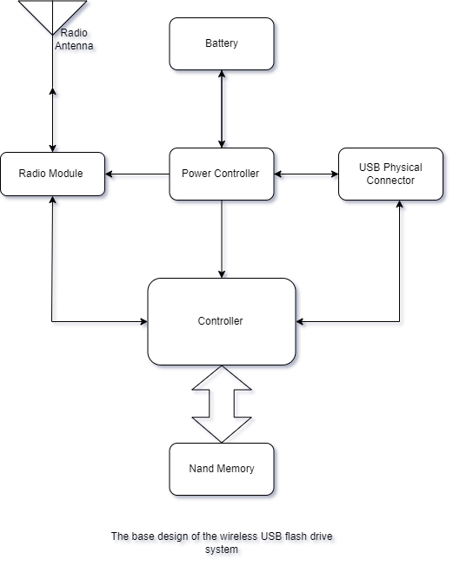

### Concept Generation

The following is a brief journey on how device and tools selection criteria was performed

First, the device systems are listed in term of their percentage to the whole project. In this case, I had six subsystem which are server, controller, Power system, Usb interface, Non-volatile Memory.

Second, for each subsystem available options were listed. The following is the table showing listed systems, available options and optimized final option

|  |  |  |  |
| --- | --- | --- | --- |
| S/N | Subsystem | Available Options | Optimized Final Option |
| 1 | Controller | ESP32, ESP82, STM32, ATMEL Series, PIC, SAMD Series | ESP32-WROVER-1E-N4R8 |
| 2 | File Sharing Server | NFS, iSCs, SMB and Apple File Protocol | SMB |
| 3 | Non-volatile  Memory | SD CARD, eMMC, NAND, NOR and UFS | NAND |
| 4 | USB interface | USB 3.0, USB 2.0, USB 1.1 | USB 2.0 |
| 5 | Power Supply System | Solar powered, Usb powered, Usb powered + battery based, rechargeable battery and non-rechargeable battery | Not decided yet, due to power calibration and uncertainty on the final product |

Third, by using concept generation such as concept table, concept fans and weight matrix options were weighted and unoptimized option were filtered until the suitable option is obtained.

### Block Diagram

Therefore, by adopting the above changes, the total system design is now according to the following diagram with exclusion of power supply subsystem

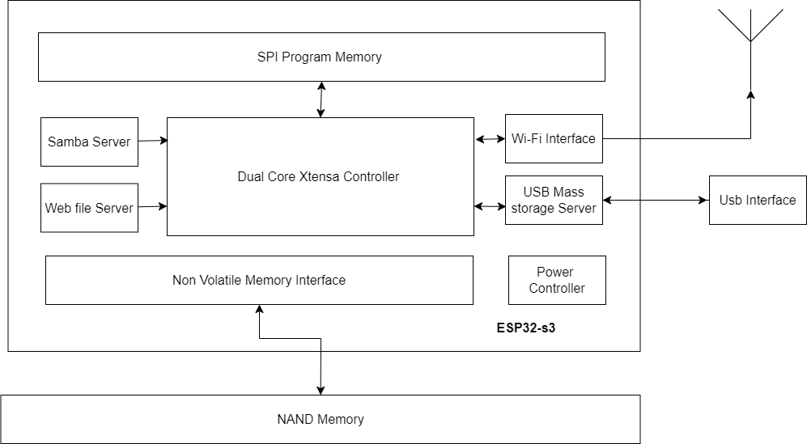

Figure 3. A modified Block diagram of a system

### Flowchart

The projects main process will be implemented through the following trends of processes

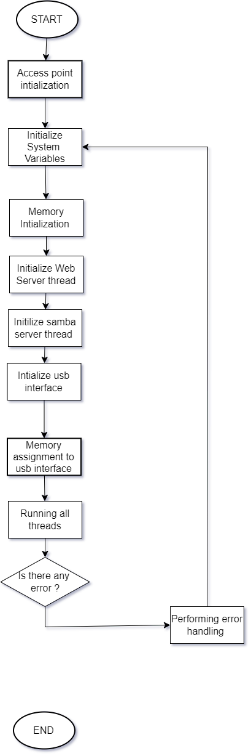

Figure 4 The main program workflow

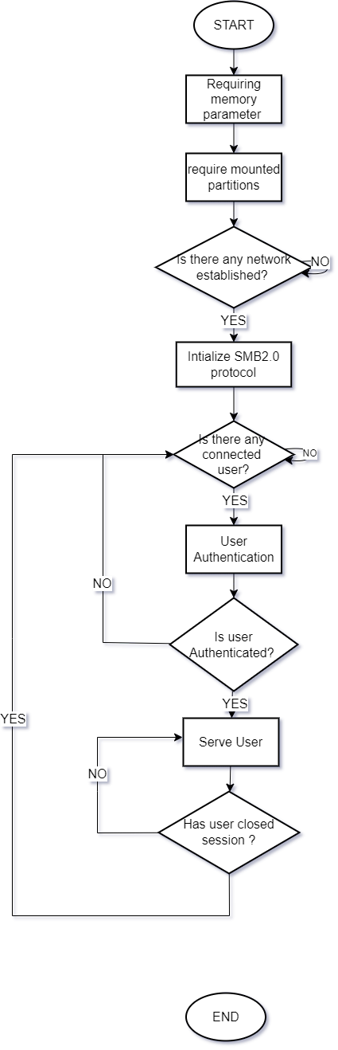

Figure 5. Samba Server Flowchart

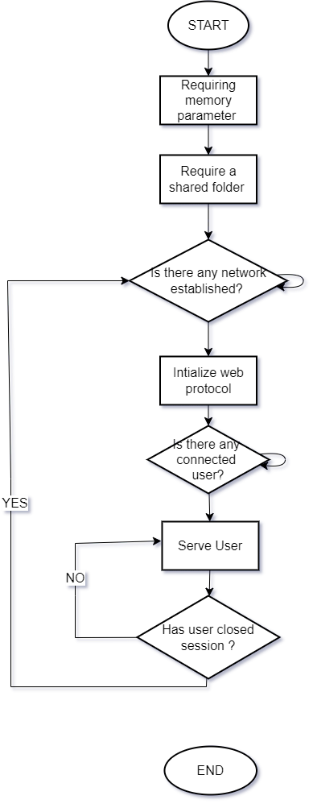

Figure 6. Web Server Flowchart

### Use Case

The diagram below shows on how the user events and processes are initiated and completed in order to achieve the main goal of this project

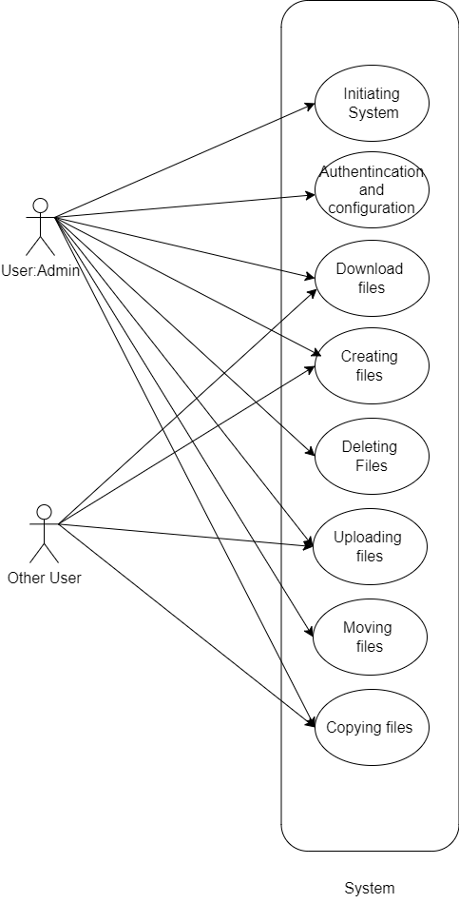

Figure 7. Use Case

### Relation Diagram

In this project there are three important classes which needs to be implemented that is server, storage, and users.

The diagram below shows the relation between each class.

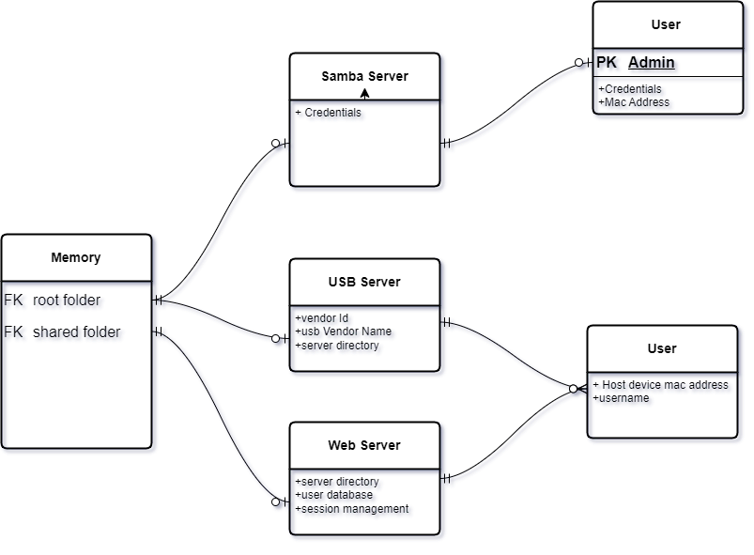

Figure 8. Entity relation diagram

### Sequence Diagram

After definition of the above flow of procedure the sequence diagram between the user and device can be figured as follows

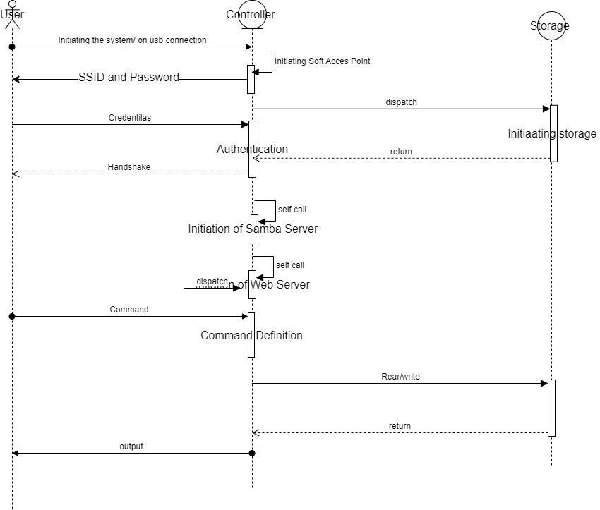

Figure 9. Sequence diagram

## CHALLENGES

Despite the minor challenges, the main challenge I was facing during implementation of project was unavailability of electricity for most of the time which led to unstable internet connection hence lag behind the schedule since the resources and simulation platform were and are still cloud based.

## WORK DONE SO FAR

Work done so far is

* total devices and tool selection criteria needed for completion of this project. Shown above.
* creating a non-reactive simple web-page for file management for the project,

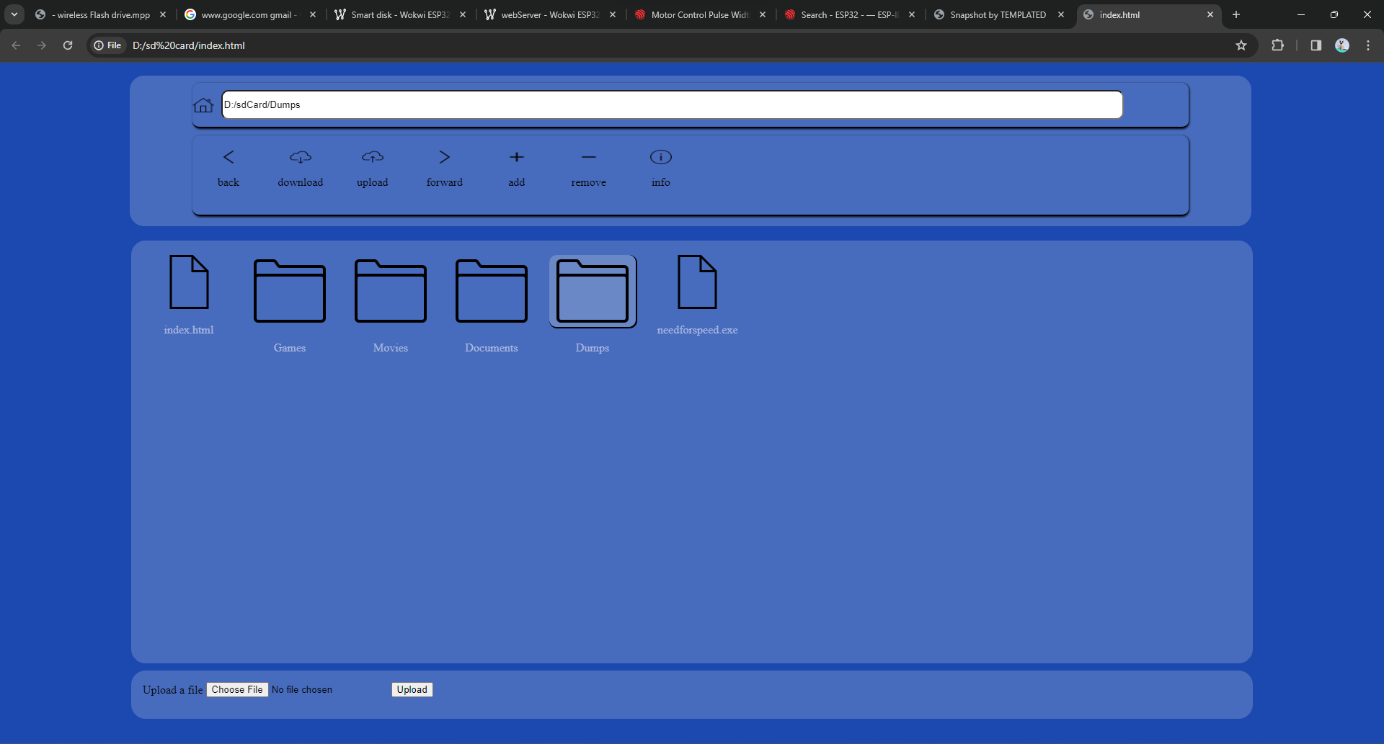

Figure 10. Web page for file management

* little progress of programming and simulations on [www.wokwi.com](http://www.wokwi.com) an Online Electronics Simulation Platform.

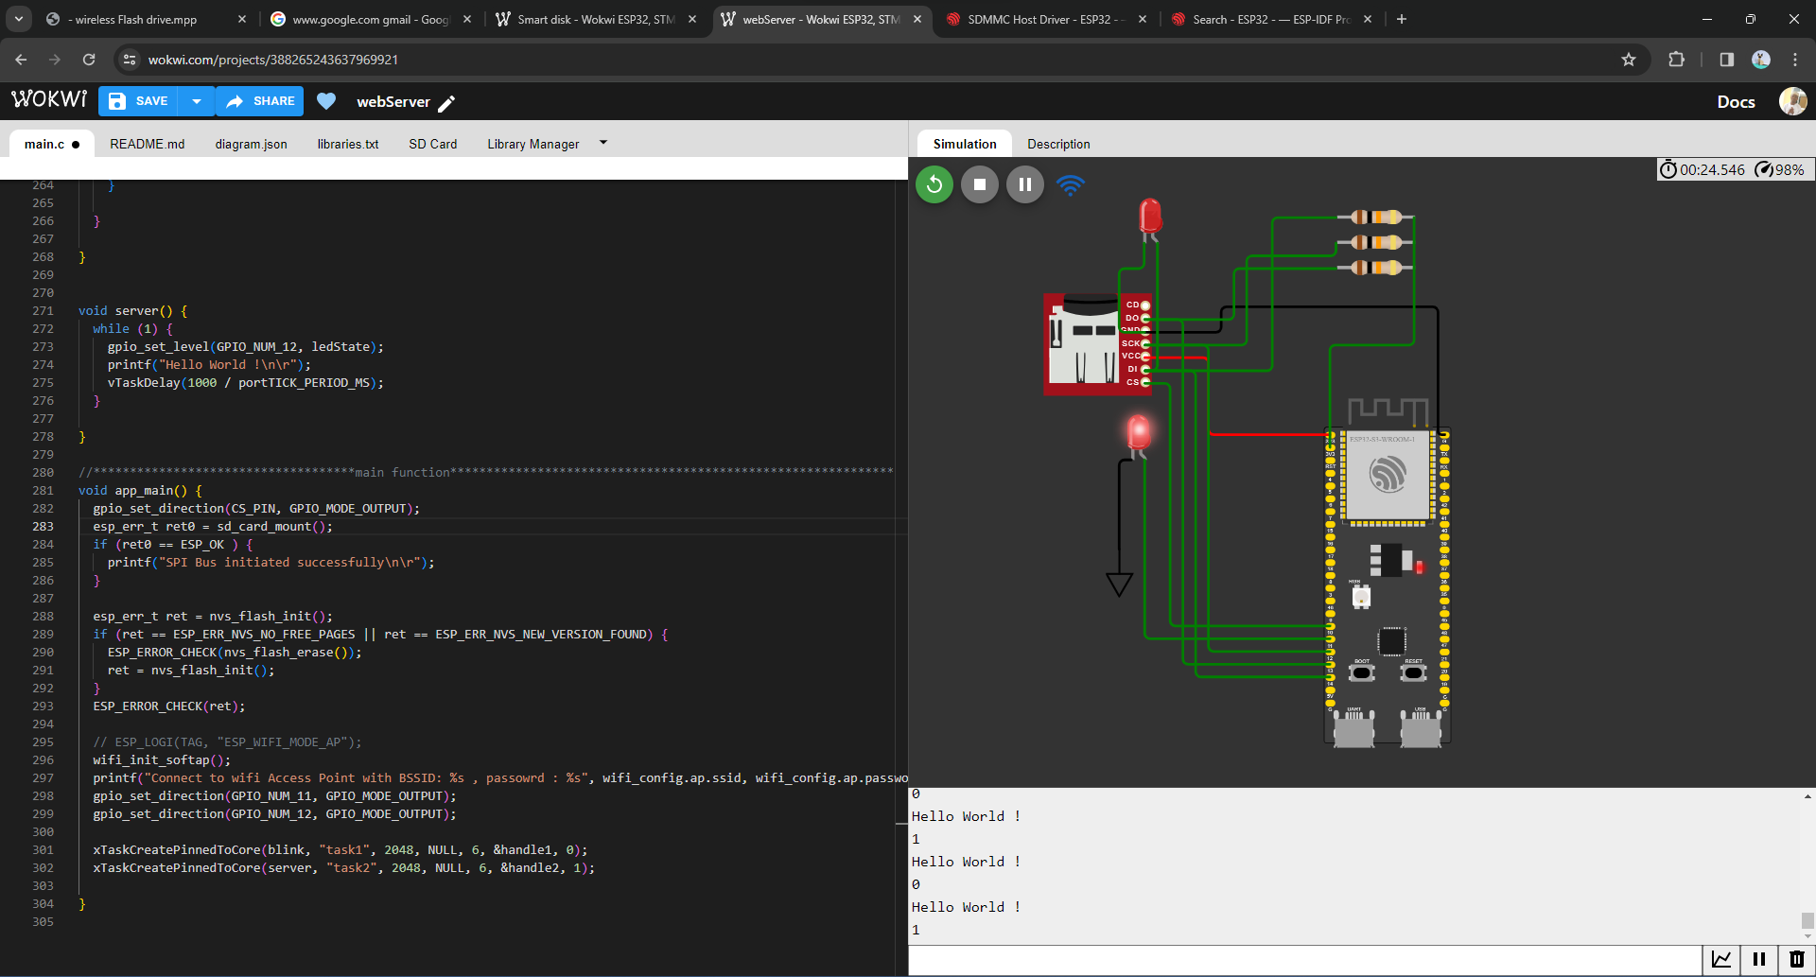

Figure 11. Simulation of Webserver on WOKWI Online Electronics Simulation Platform

## TIME SCHEDULE

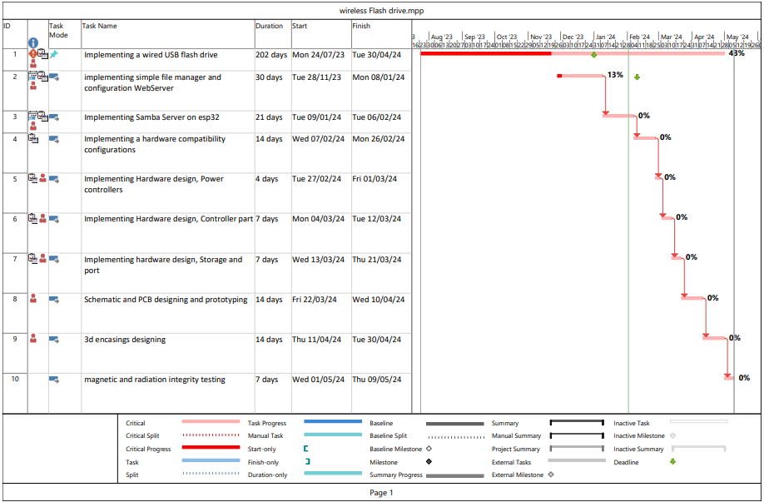

Figure 12 Gantt chart

## BUDGET

This table comprise of the cost that are expected to be used as per initial design and may change due to change in scope

|  |  |
| --- | --- |
| Components | Cost (Tsh) |
| Esp8266 nodeMcu module | 20000/= |
| Memory card | 10000/= |
| Memory card module | 8000/= |
| Esp32 s3 | 45000/= |
| Breadboard | 15000/= |
| Lithium-ion Battery | 20000/= |
| Battery controller (MP2731) | 5000/= |
| Nand memory storage chip | 5000/= |
| Connecting wires | 10000/= |
| USB connector | 1000/= |
| Internet Access | 100000/= |
| 3D encasing | 50000/= |
| Total | 289000/= |

# REFERENCES

al, J. W. (2016). A Survey of Mobile Storage Systems: Flash Drives, SD Cards, and Wireless Flash Drives .

Barnes, R. (2017). Make a Pi Zero W Smart USB flash drive. The MadPi Magazine.

Bez, R. (2004). Non-volatile memory technologies: emerging concepts and. Materials Science in Semiconductor Processing 7 (2004) 349–355, 7.

Bogart, D. J. (1995). Magnetic Tape Storage and handling . National Medial Lab.

Czapor, J., Hartney , B., & Knight , A. (2006). Wireless USB Flash Storage Device. google scholar.

Digital, W. (2022). Wireless Flash Drive: End of Support. United States: Wetsern Digital.

Hyperstone. (2020). Introduction to: Non Volatile Memory. Hyperstone. Retrieved from www.hyperstone.com

IEEE. (2007). For Wireless USB, the Future Starts Now. IEEE.